Chapter 12, Problem 58.

Solve Prob. 12.10 using PSpice.

Chapter 12, Problem 10.

For the circuit in Fig. 12.43, determine the current in the neutral line.
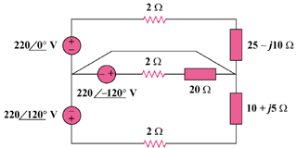
440∠0˚ V
440∠120˚ V
440∠–120˚ V

Figure 12.43
For Prob. 12.10 and 12.58.

